JoymarKet Application Guide

On the Login View, please enter the email and password of your accont. Then, click Login.
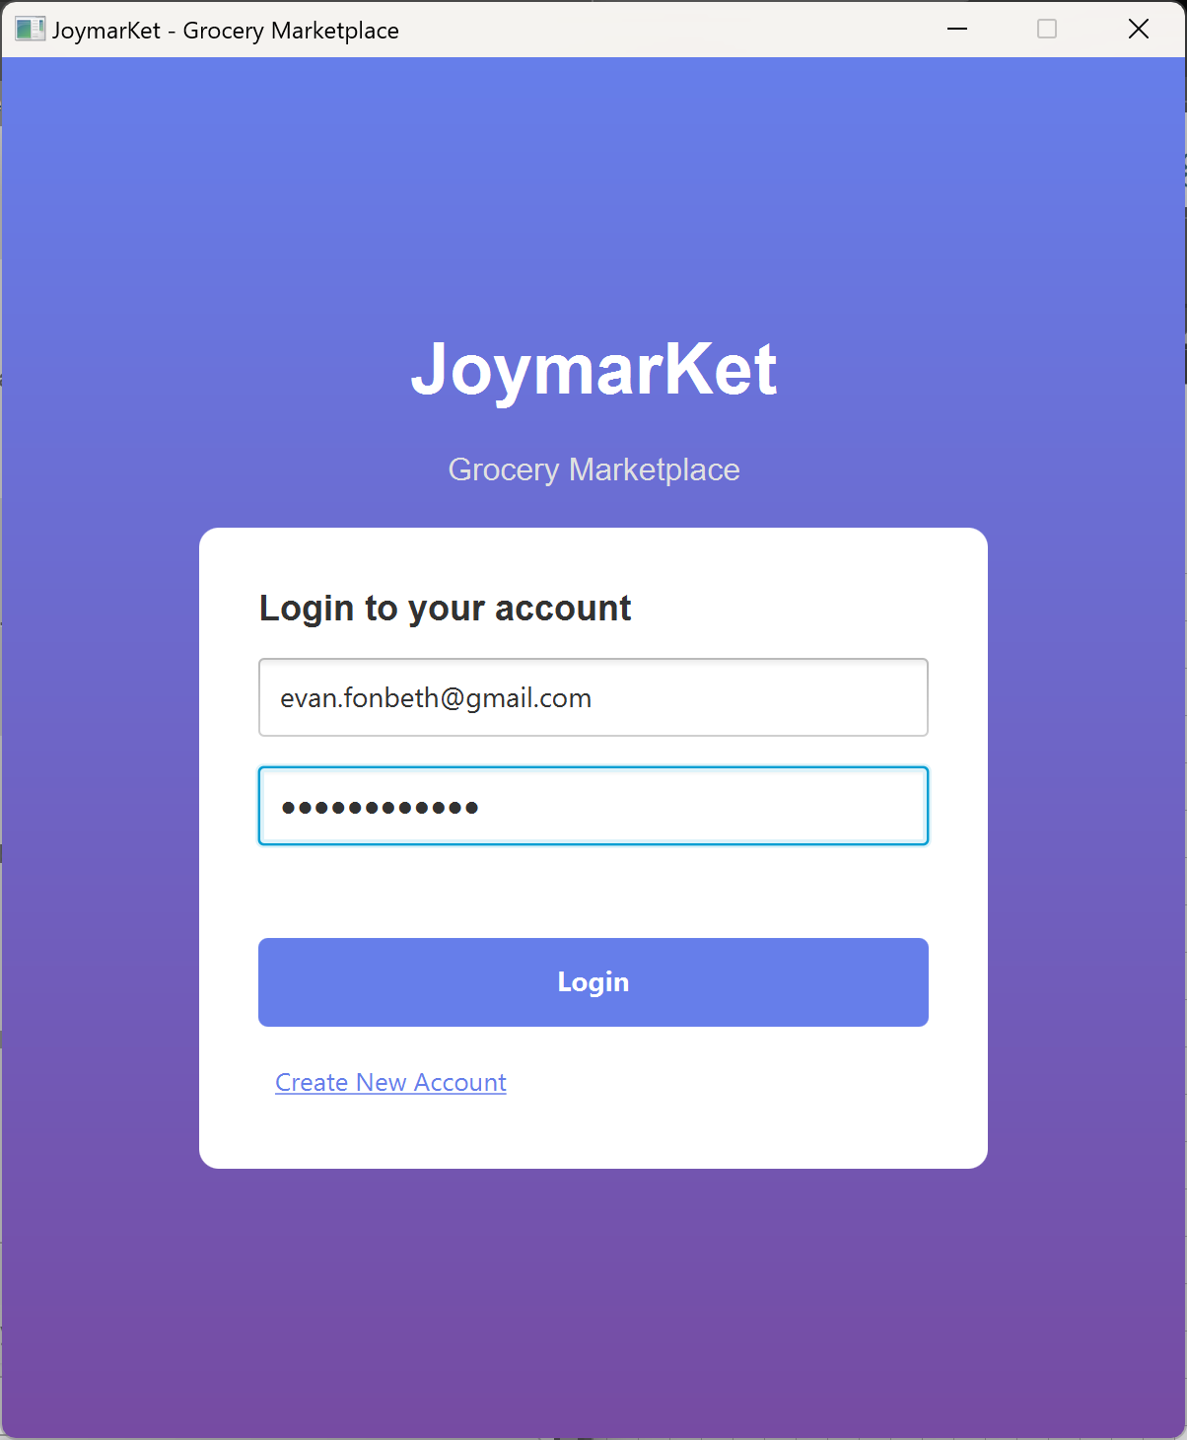

If you have not register an account, click Create New Account. On the Register Account View, please input your full name, email (must ends with ‘@gmail.com’), password (min. 6 characters), confirm password (must match with the inputted password), phone number (10-13 digits), address. Then, click Register to register your account. If you wish to go back to the Login View, click Back to Login.
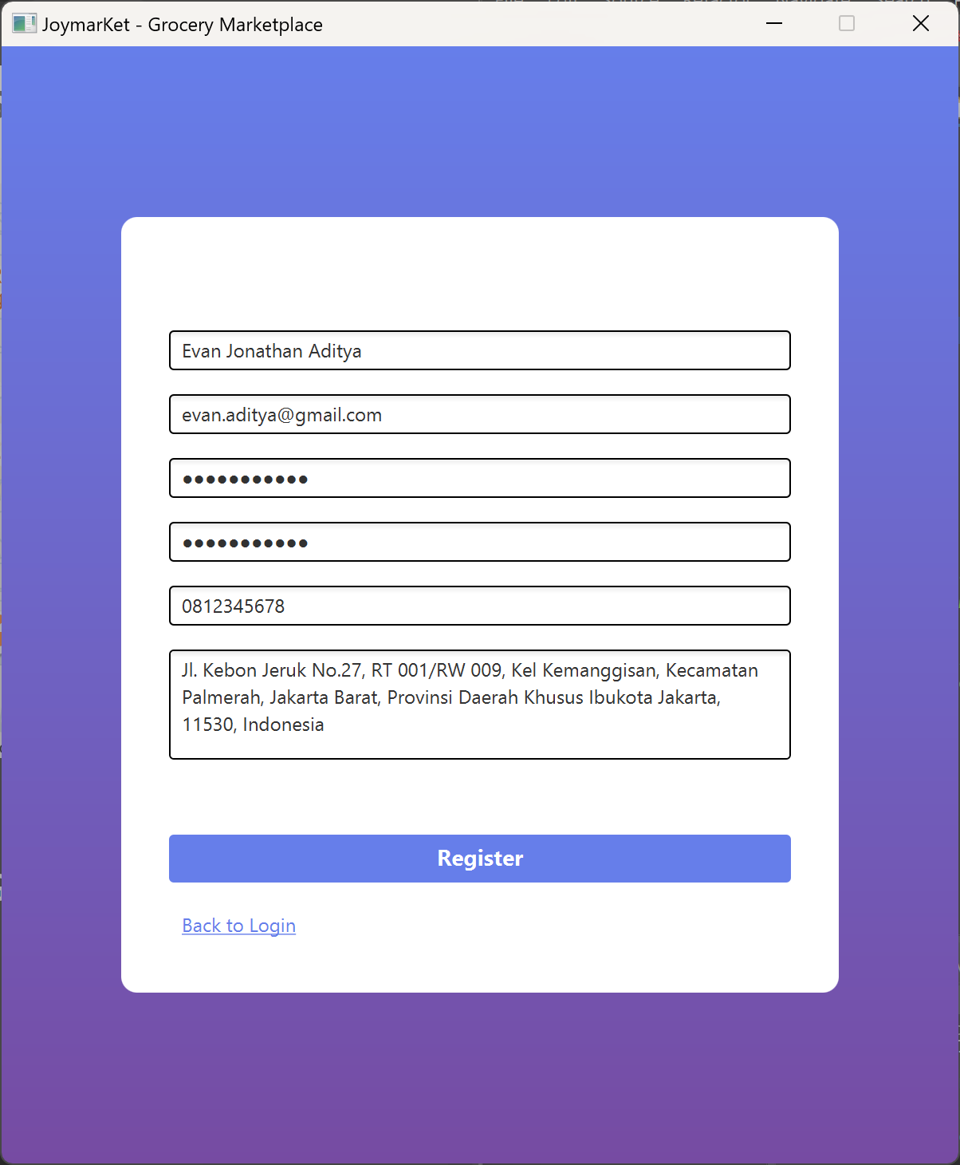

After making sure all the fields have been filled, click Register. An alert with the message ‘Registration successful! Please login’ will appear, click OK and you will be directed back to the Login View. Then, input the email and password to your accont on the Login View.
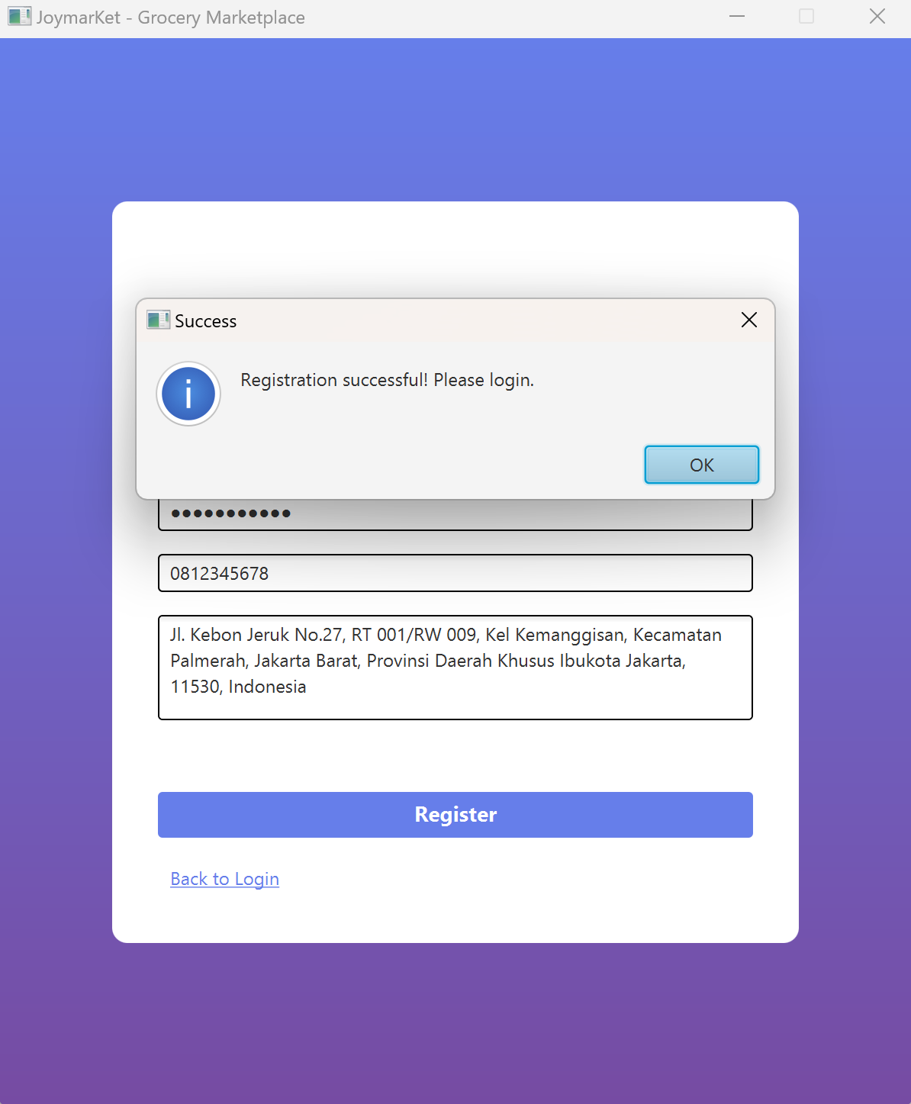

If you are logged in as a Customer, you will be directed to the Customer Dashboard. On the dashboard, you will see your full name and current balance.
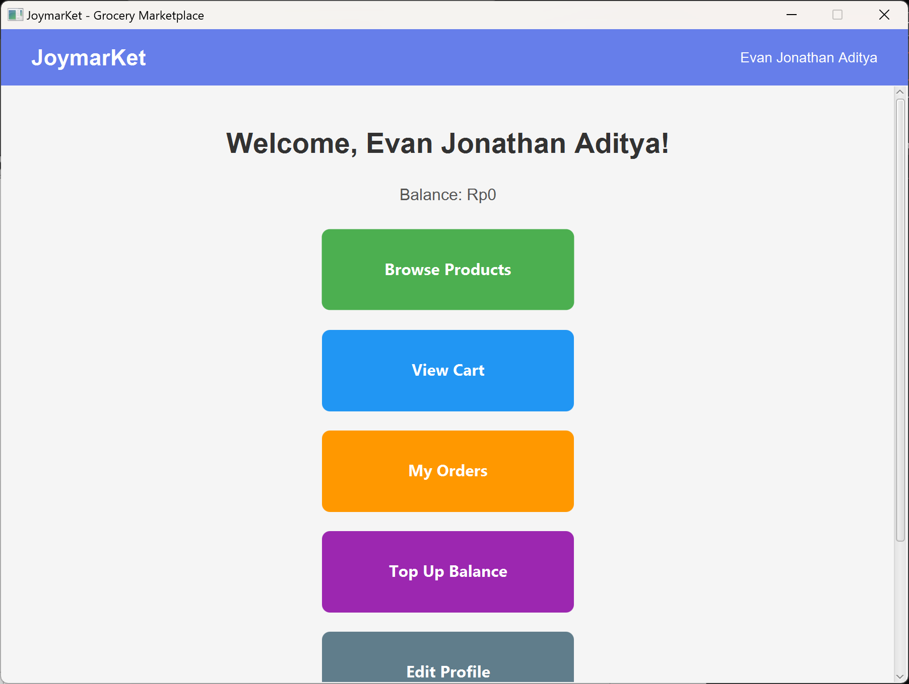

To browse available products, click Browse Products. You may scroll down to see more details of all available products. To add a product to your cart, input the amount of product, then click Add to Cart. An alert with the messsage ‘Added to cart!’ will apear, then click OK. If you wish to go back to your dashboard, click Back to Dashboard.
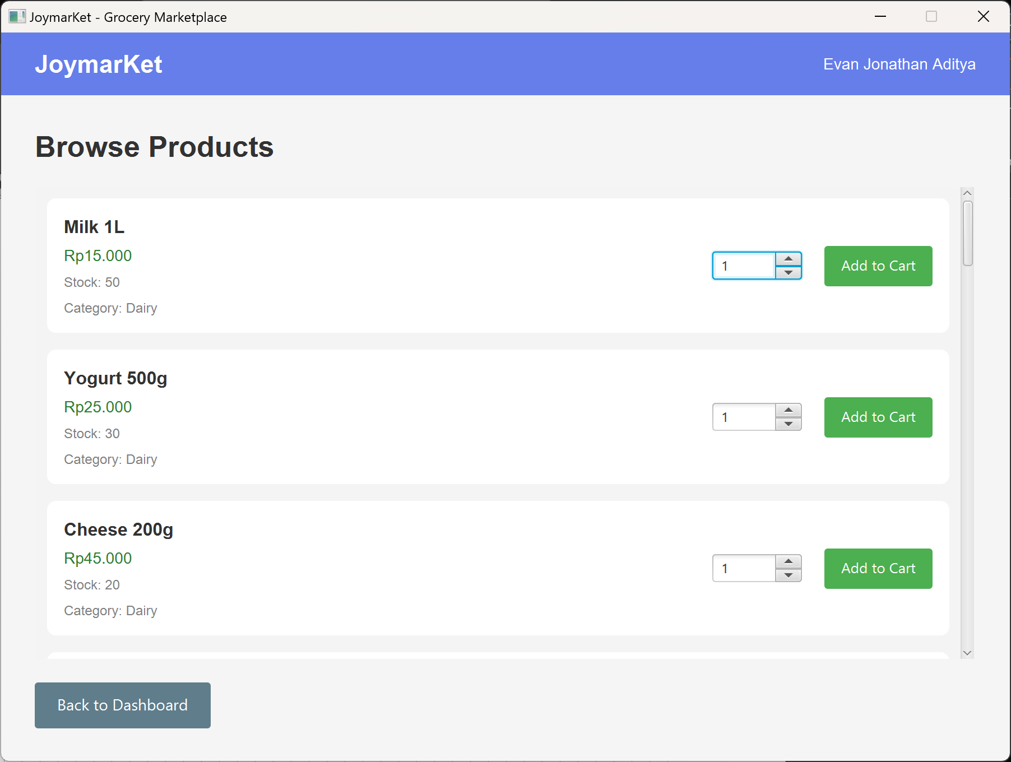
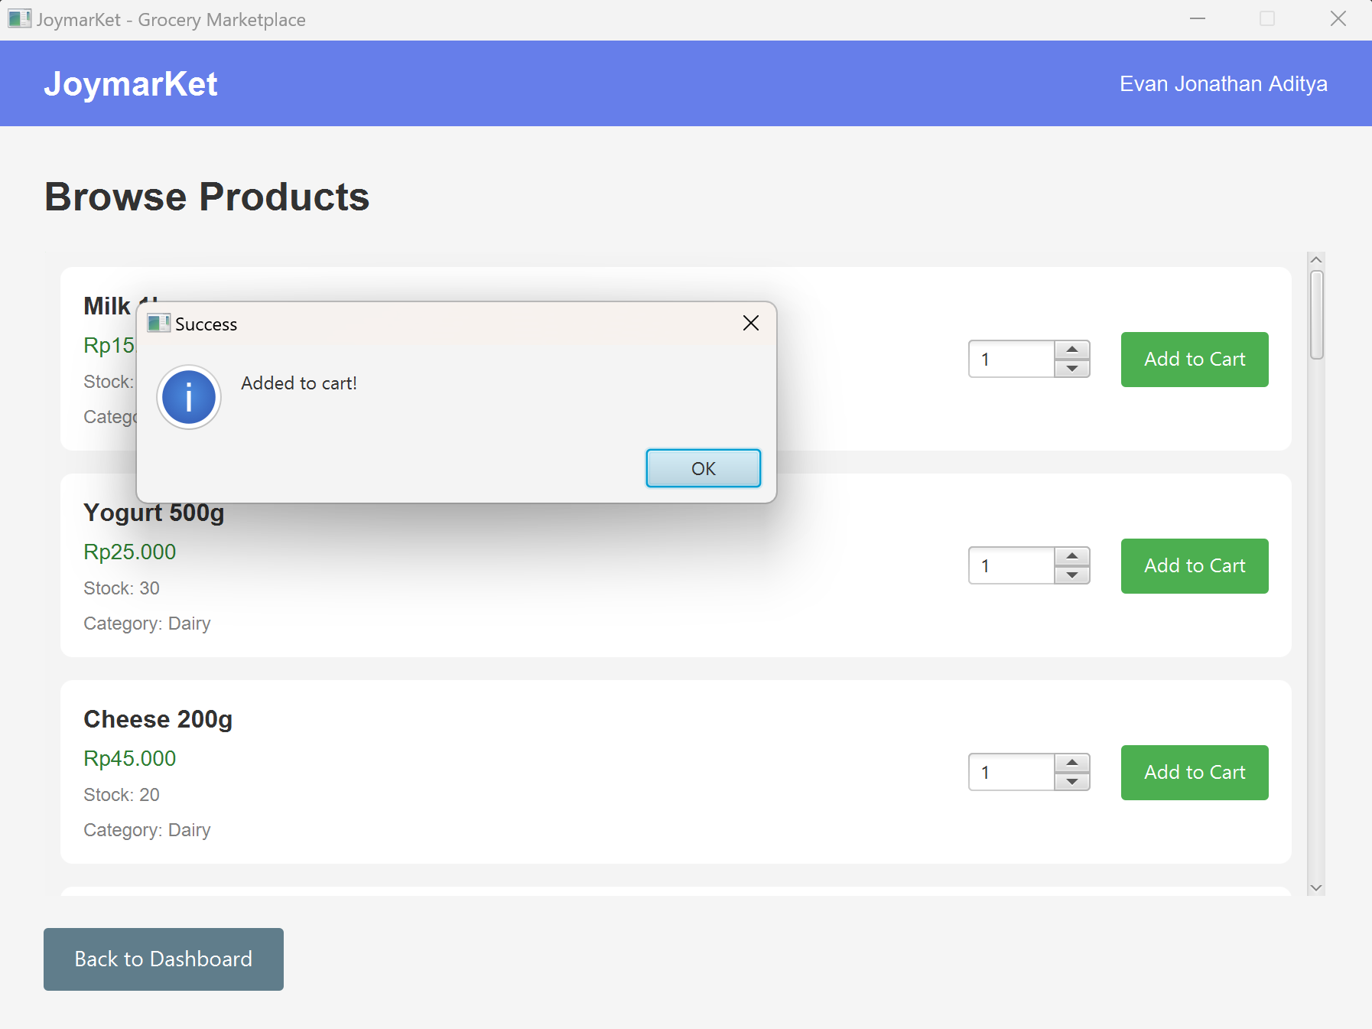

To view your cart, click View Cart on your dashboard. You may scroll down to see the details of the products you have added to your cart. To remove a product from your cart, click Remove. The subtotal of all the products in your cart are automatically calculated and displayed on the bottom of the view. If you have a promo code, you may input the promo code to claim the benefit. If you are ready to check out your cart, click Checkout. If your cart has been succesfully checked out, an alert with the message ‘Order placed successfully’ will appear, then click OK. If you wish to go back to your dashboard, click Back.
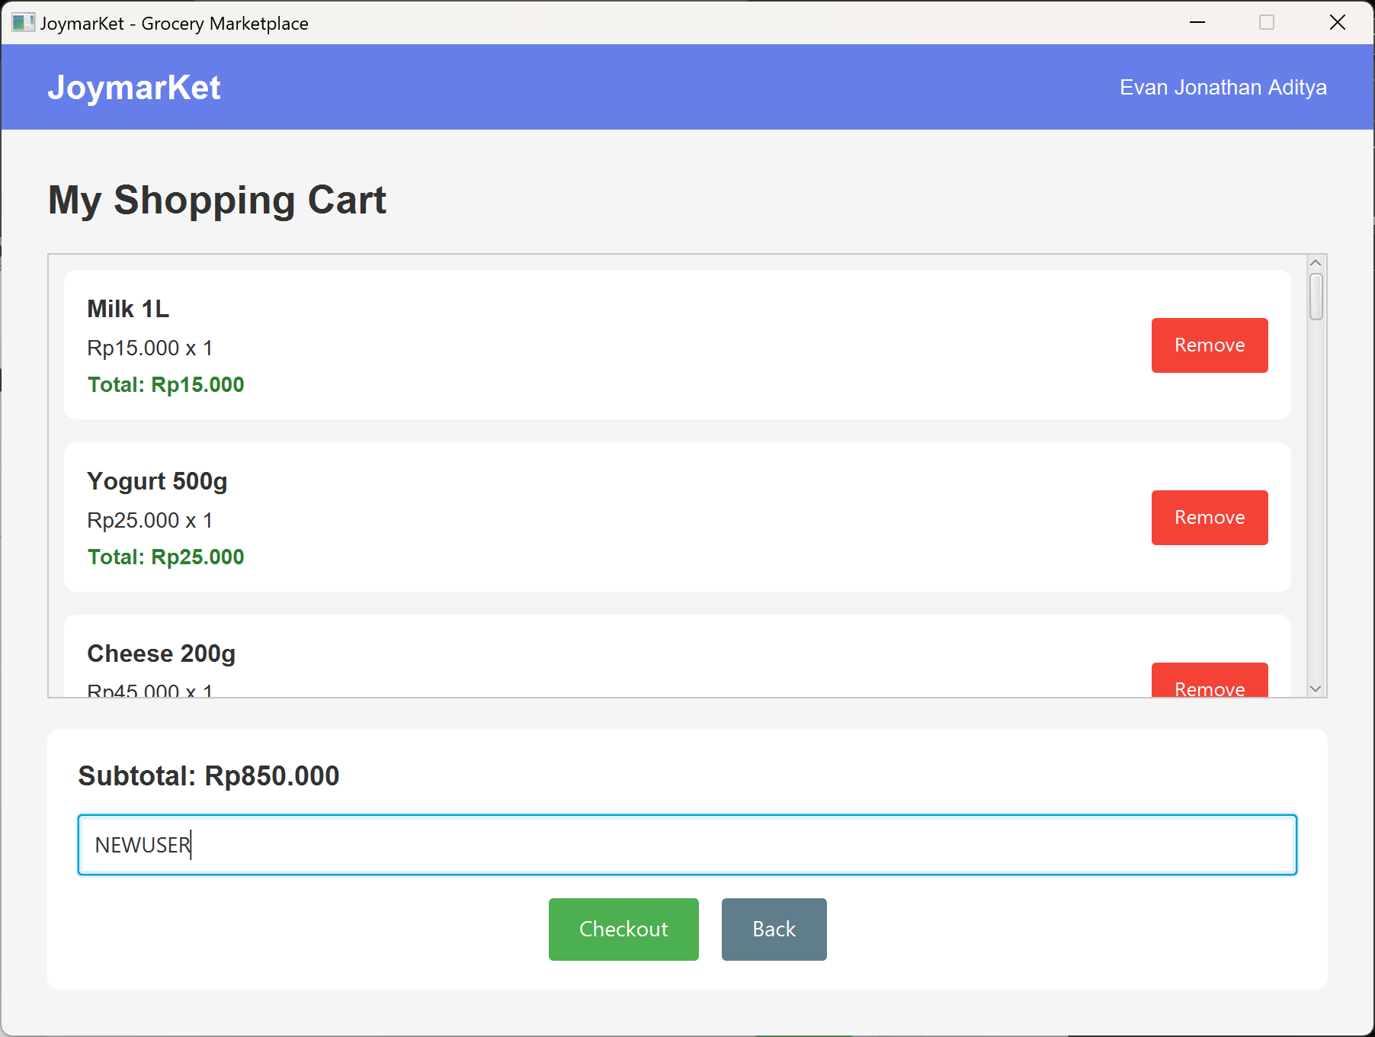
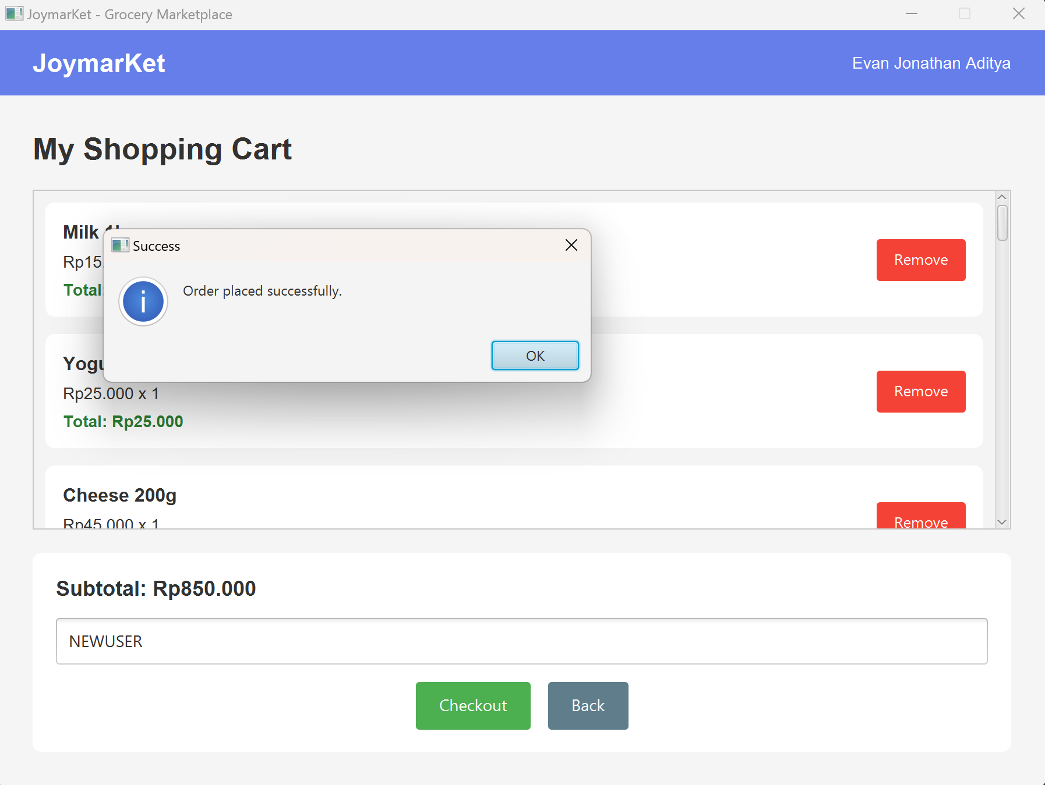

To view all your purchased orders, click My Orders on your dashboard. You may scroll down to see the details of your purchased orders. To go back to your dashboard, click Back to Dashboard.
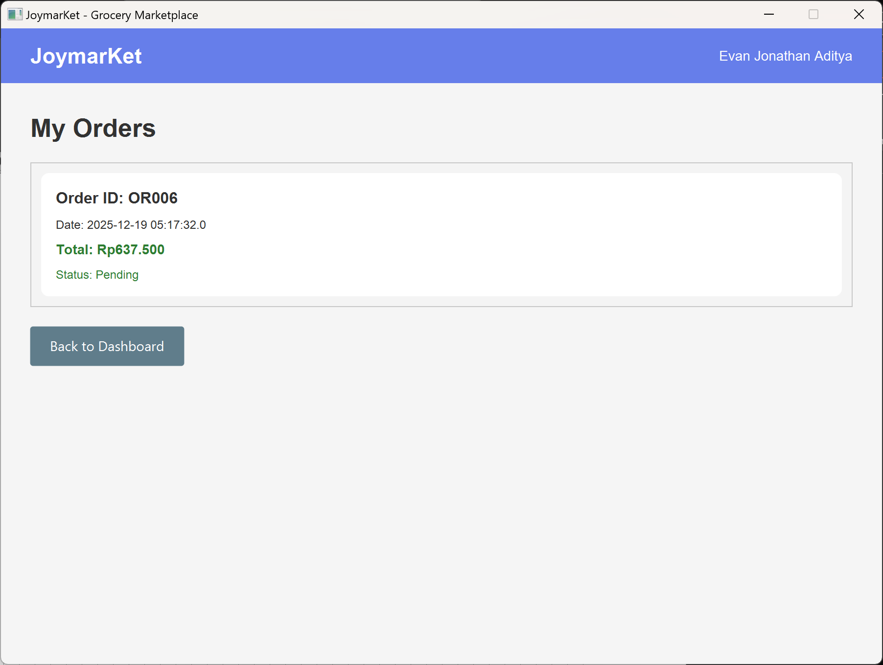

To top up your balance, click Top Up Balance on your dashboard. Input your desired amount to add to your balance (the minimum top-up amount is Rp10.000). To proceed to add the funds to your account, click Top Up. An alert with the message ‘Successfully topped up...’ will appear, then click OK. If you wish to cancel, click Cancel.
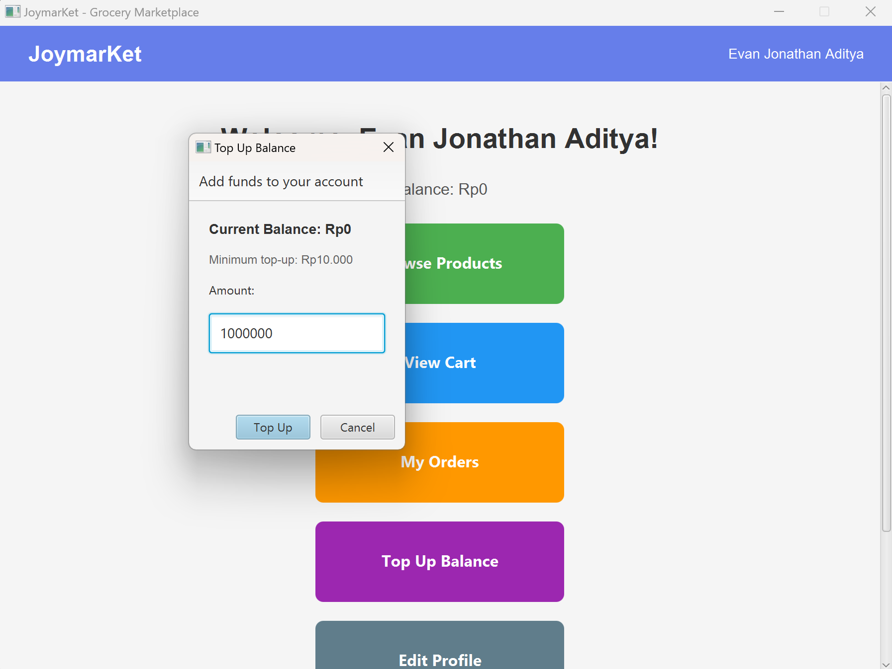
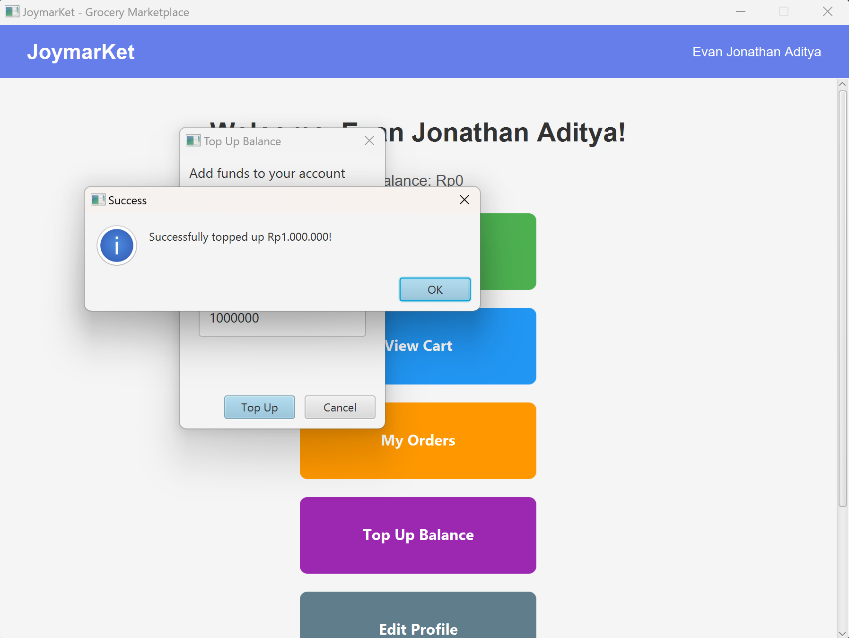

If you are logged in as a Courier, you will be directed to the Courier Dashboard. On the dashboard, you will see your full name and your vehicle details.
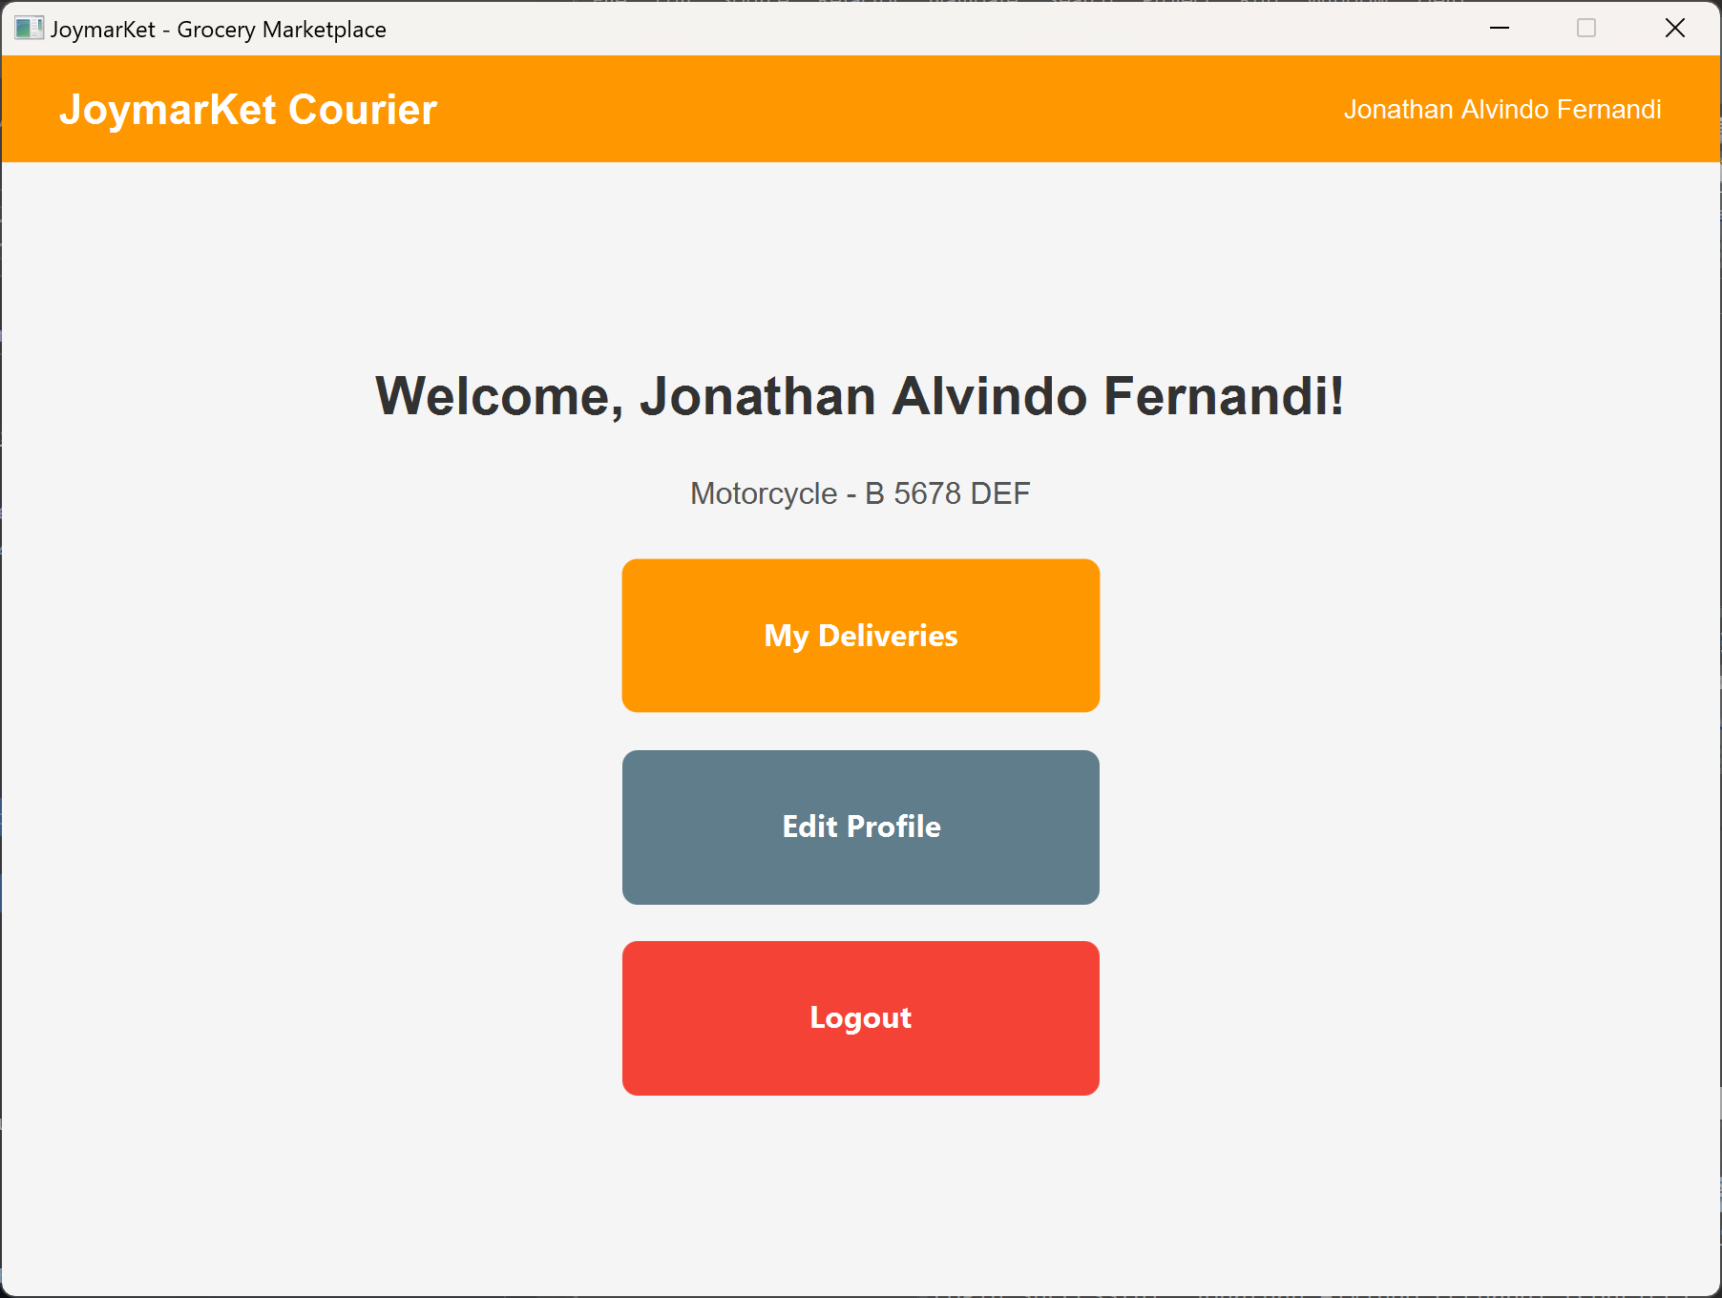

To view all deliveries assigned to you, click My Deliveries. You may scroll down to see the details of the deliveries assigned to you. To update the status of a delivery, click the ‘Updated to:’ dropdown and select a status, then click Update Status. If you wish to go back to your dashboard, click Back to Dashboard.
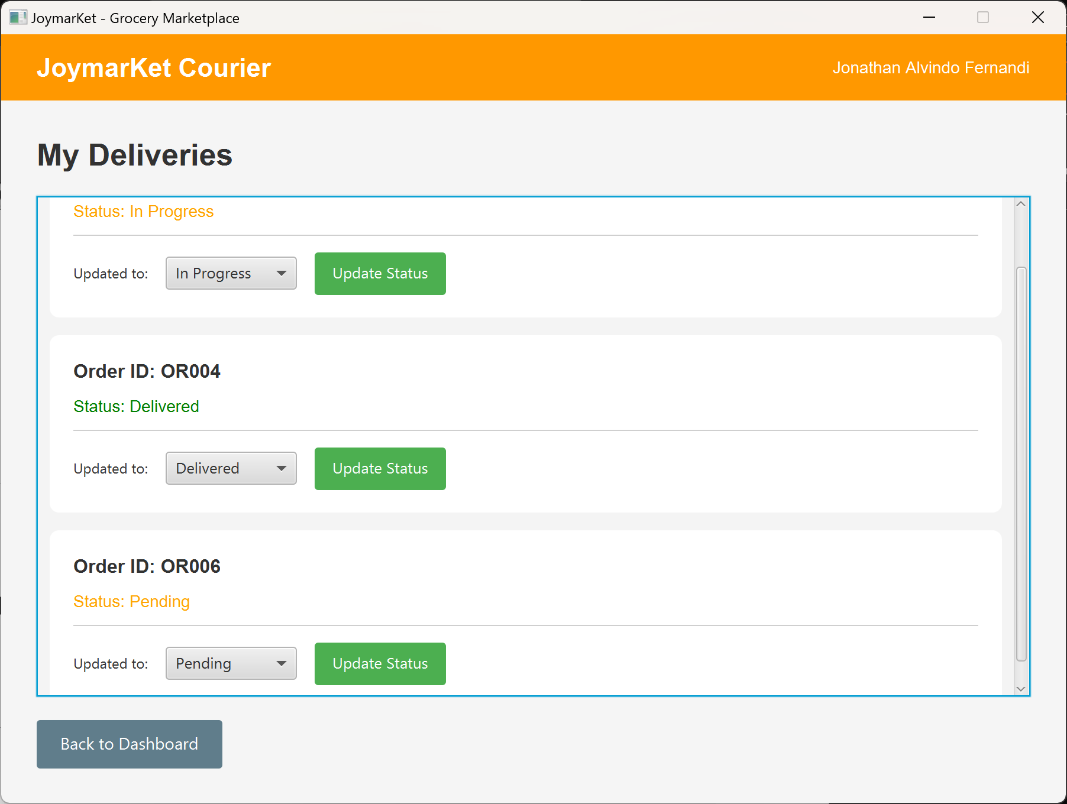
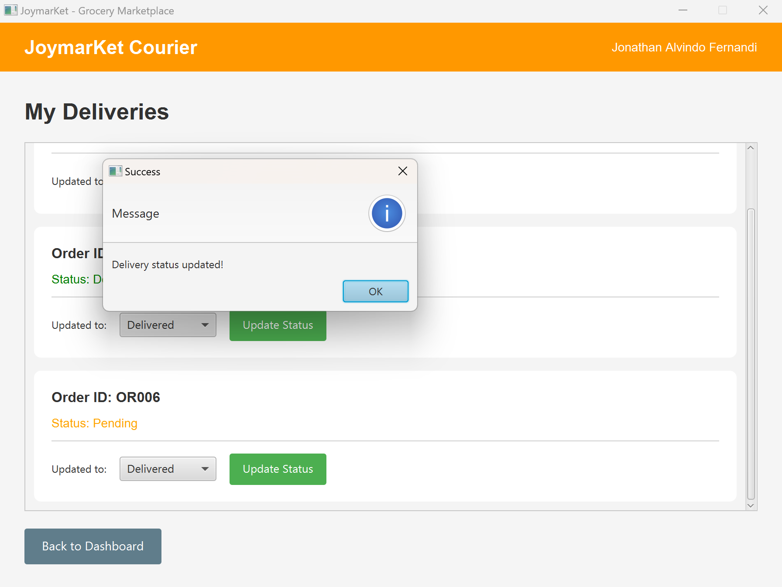

If you are logged in as an Admin, you will be directed to the Admin Dashboard. On the dashboard, you will see your full name.
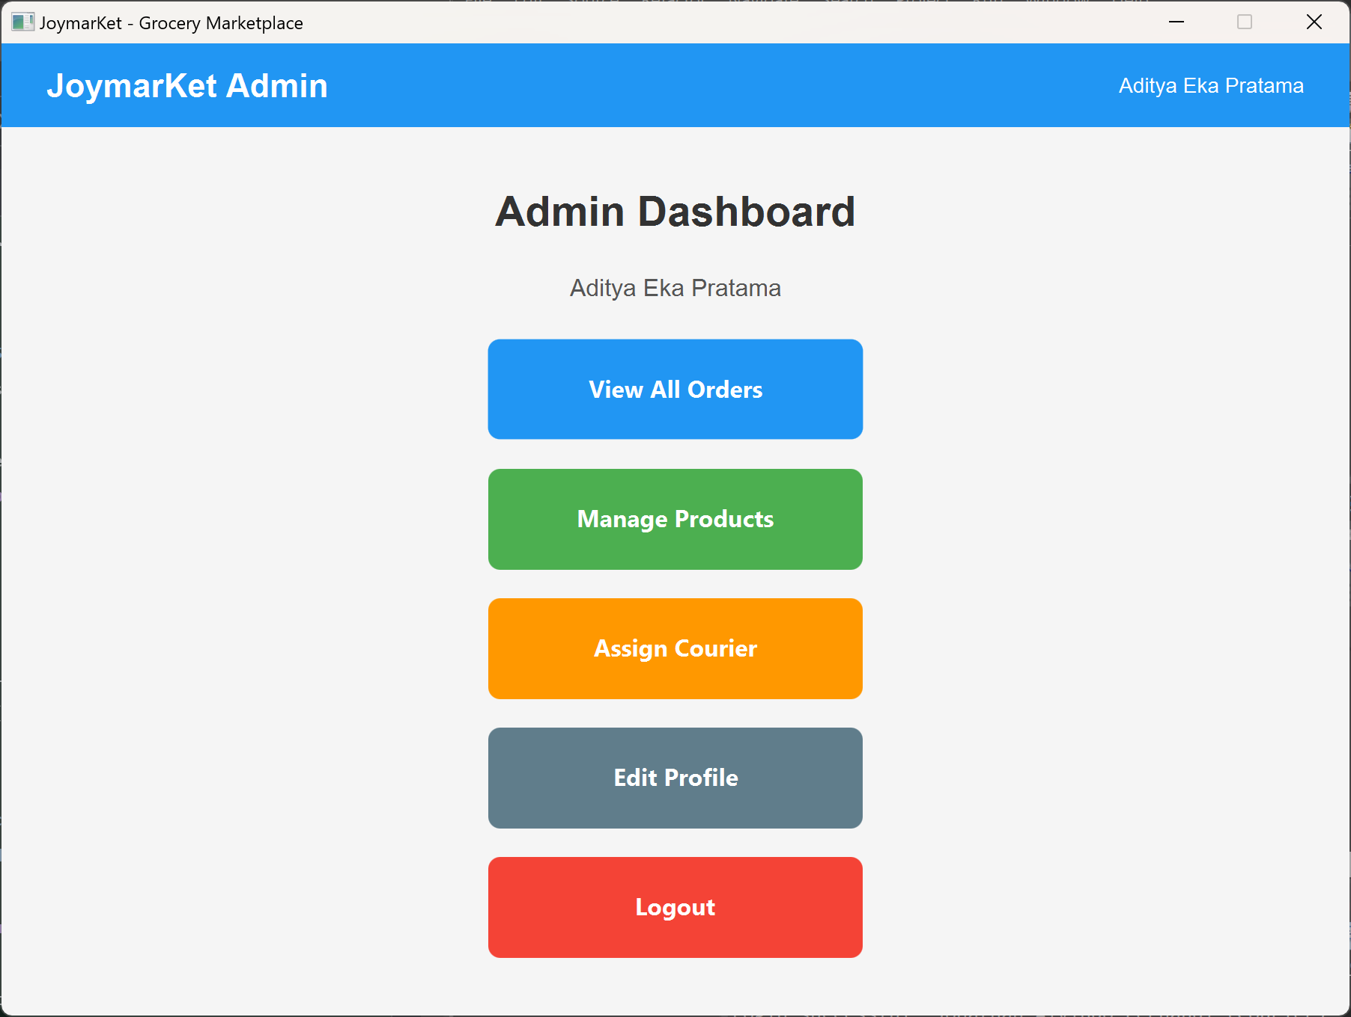

To view all orders, click View All Orders. You may scroll down to see the details of all orders. To go back to your dashboard, click Back to Dashboard.
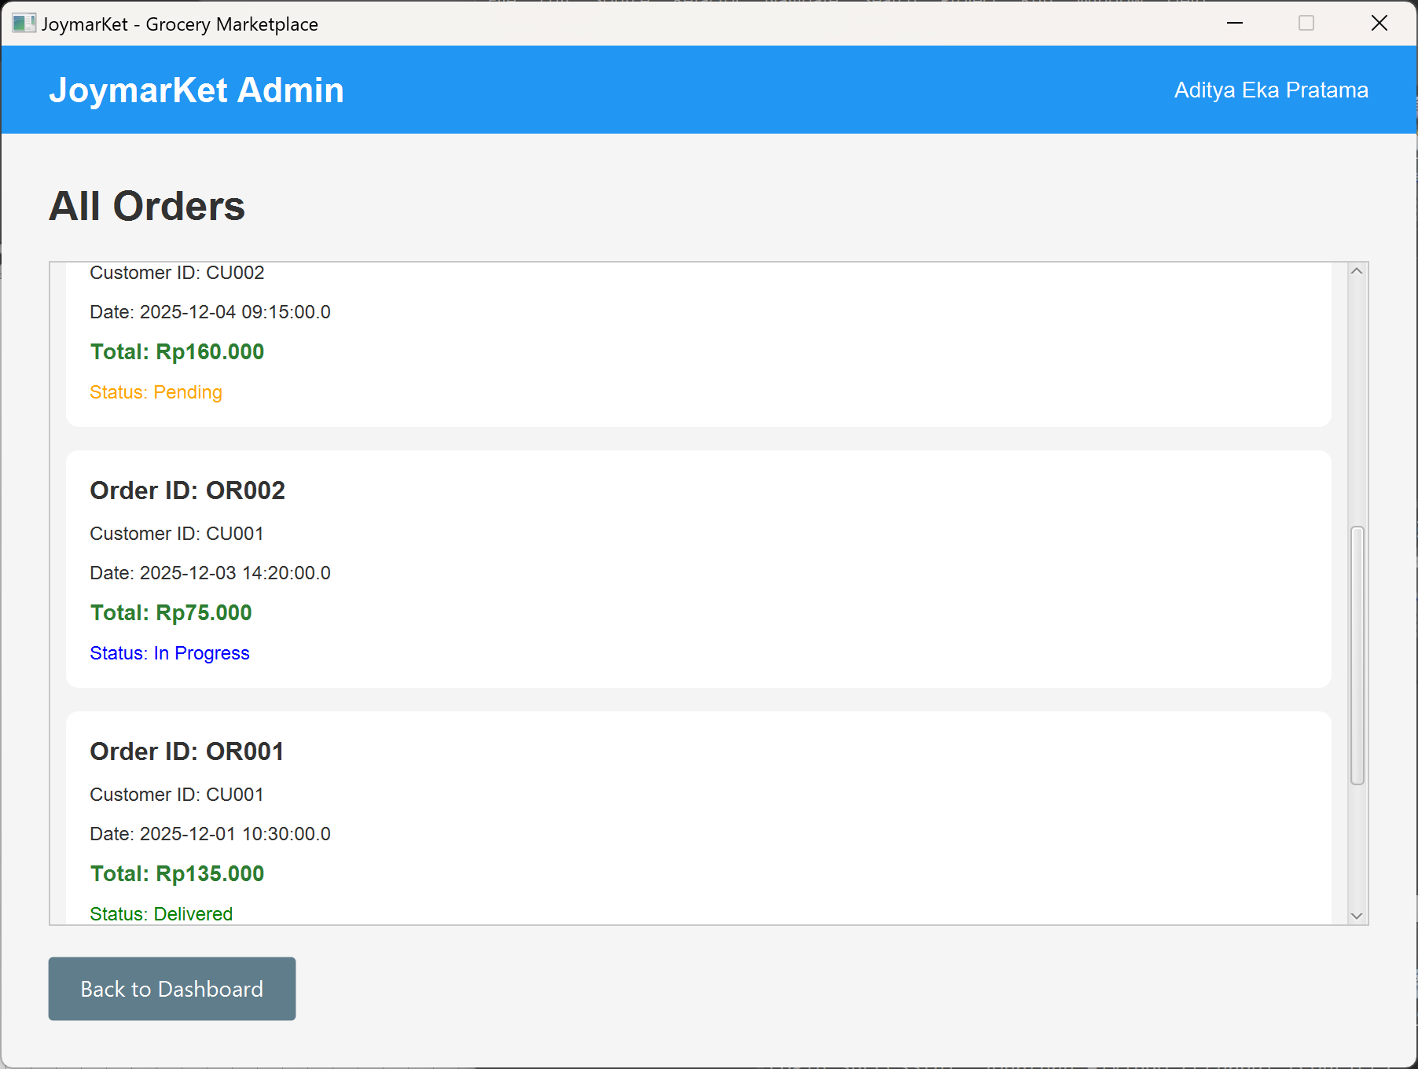

To manage all products, click Manage Products on your dashboard. To update the stock of a product, input the updated stock amount in the ‘Update stock:’ field, then click Update Stock. An alert with the message ‘Stock updated!’ will appear, then click OK. If you wish to go back to your dashboard, click Back to Dashboard.
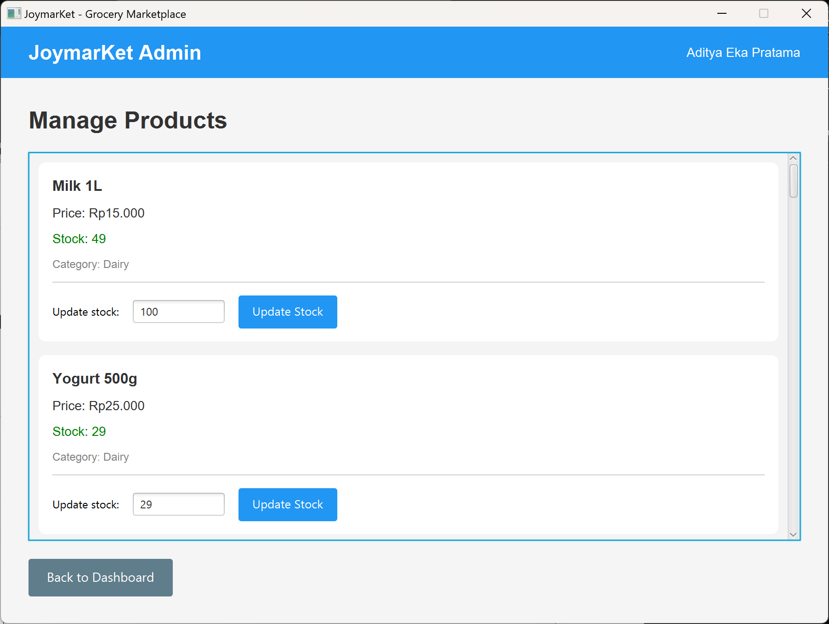
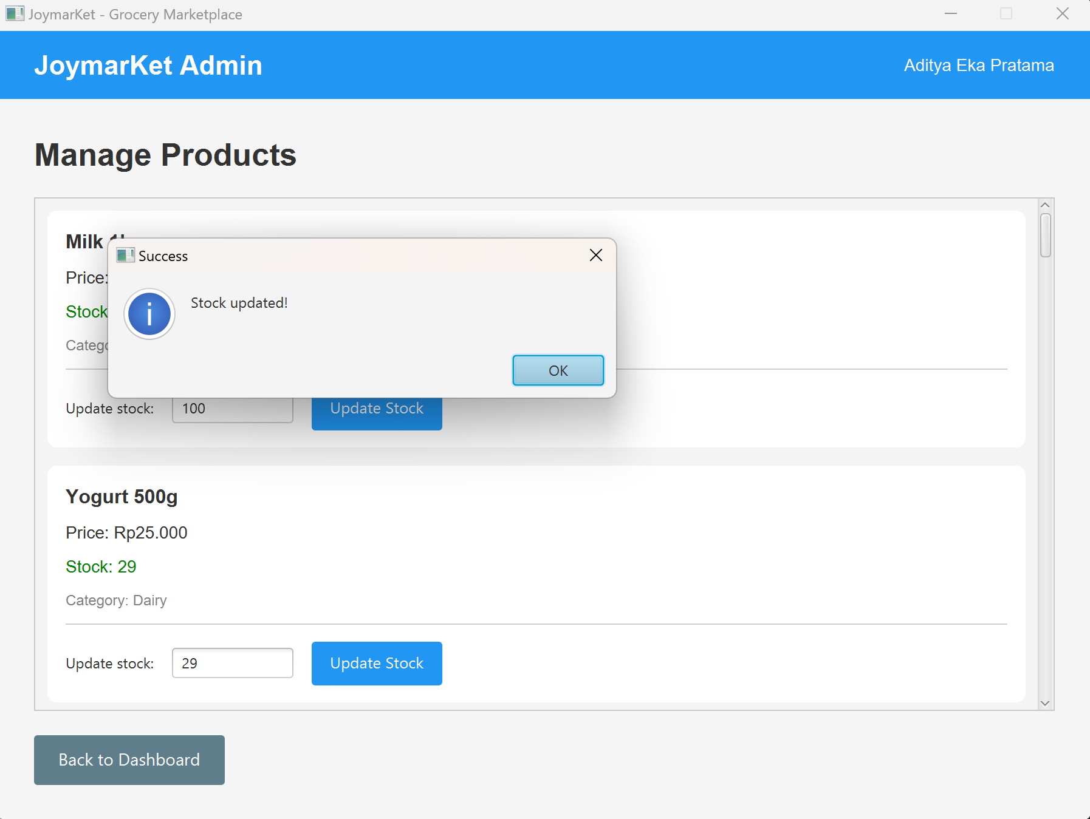

To assign deliveries to couriers, click Assign Courier on your dashboard. Select an order to be delivered from the ‘Select Order:’ dropdown and a courier from the ‘Select Courier:’ dropdown. To proceed to assign the courier to the order, click Assign. An alert with the message ‘Courier assigned successfully!’ will apear. If you wish to go back to your dashboard, click Back to Dashboard.
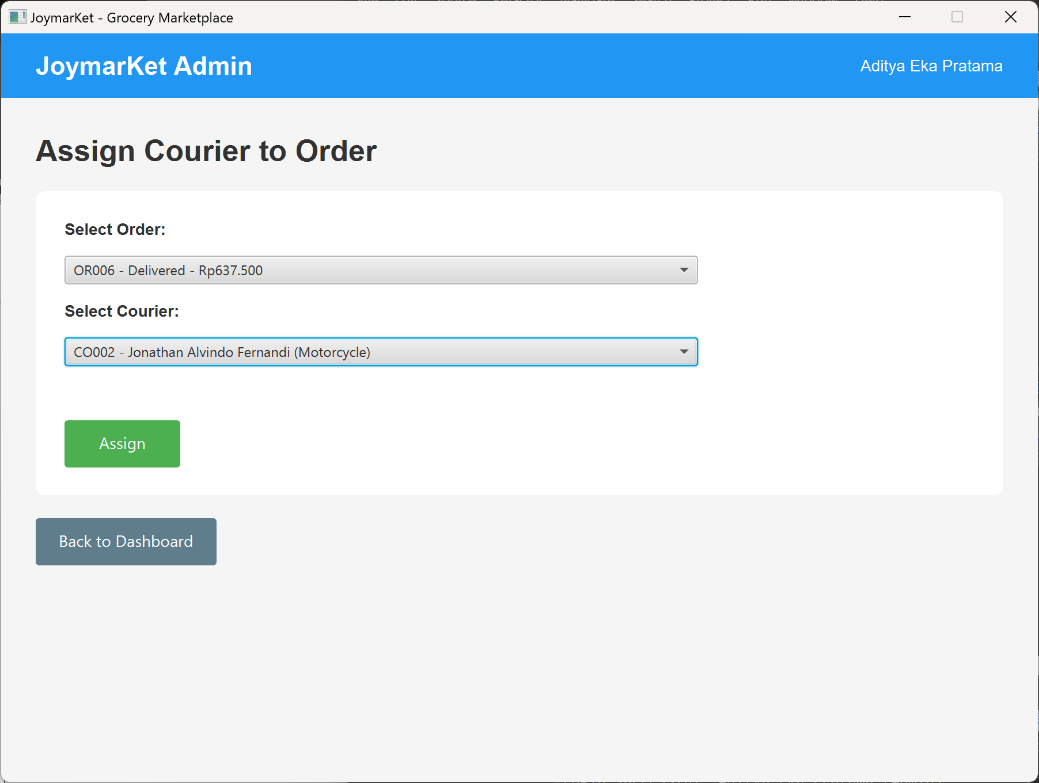
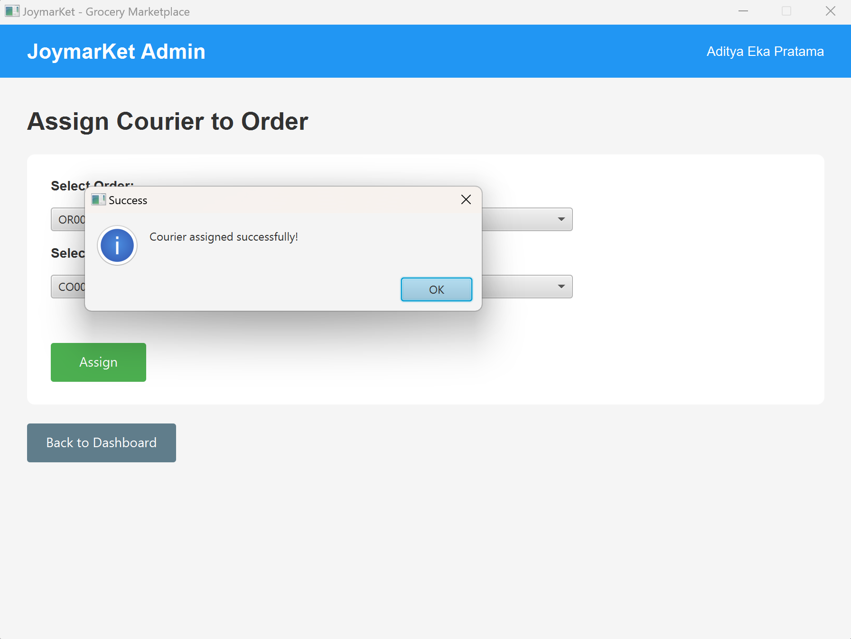

To edit your profile, click Edit Profile on your dashboard. You may edit your full name, phone, and address. However, you can not change the email of your account. To confirm your edit, click Save Changes. An alert with the message ‘Profile updated successfully!’ will appear, then click OK. If you wish to go back to your dashboard, click Cancel.
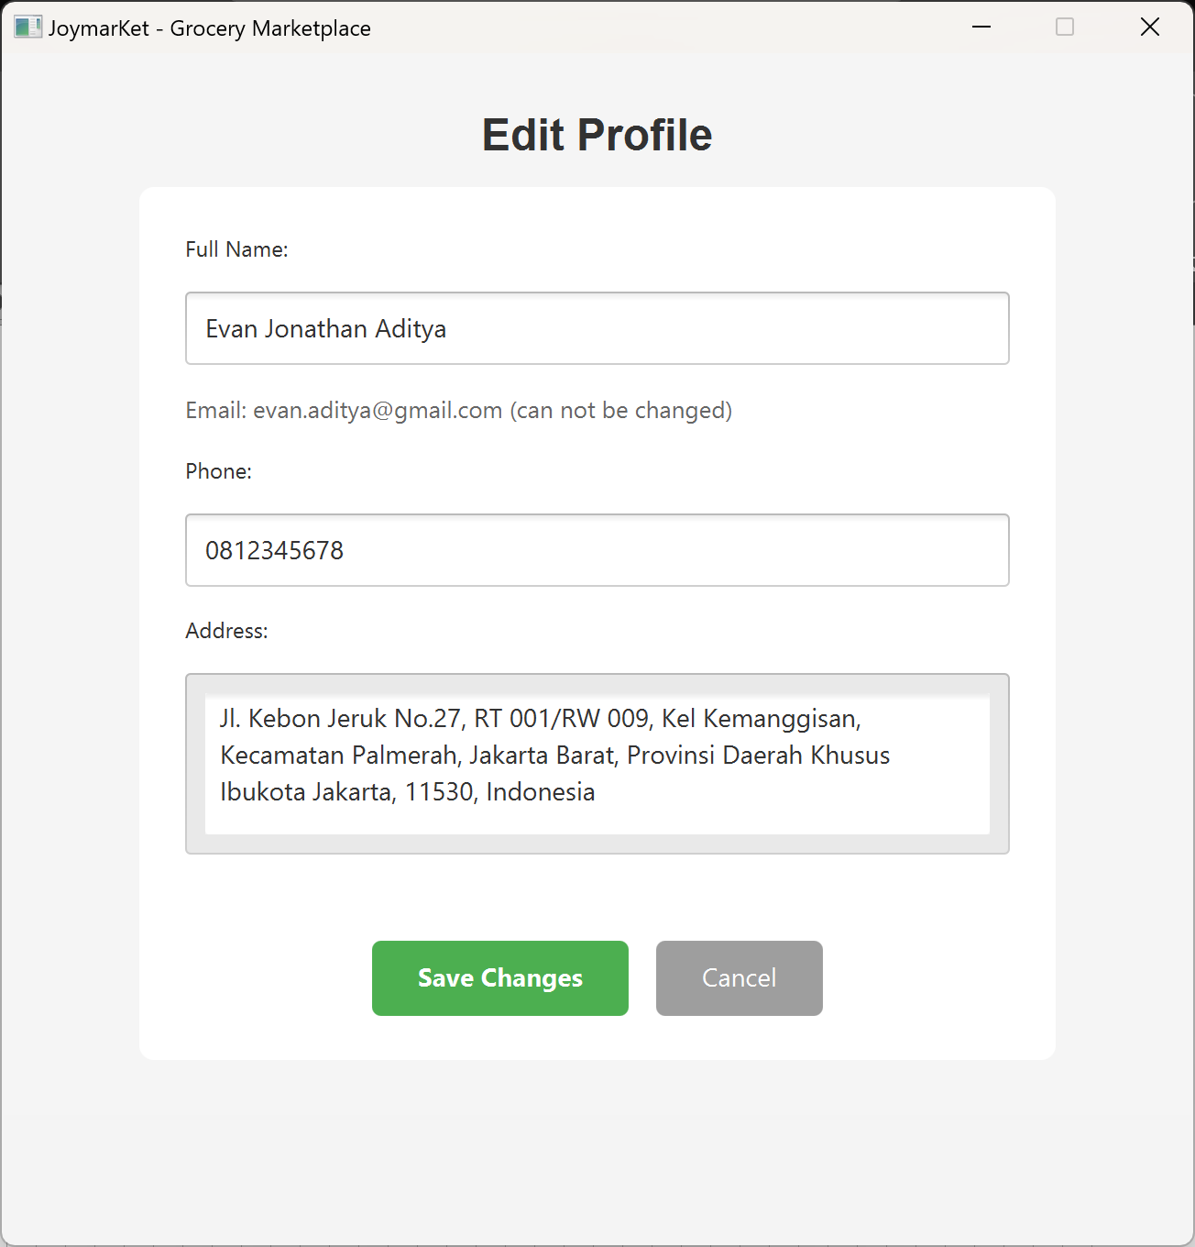
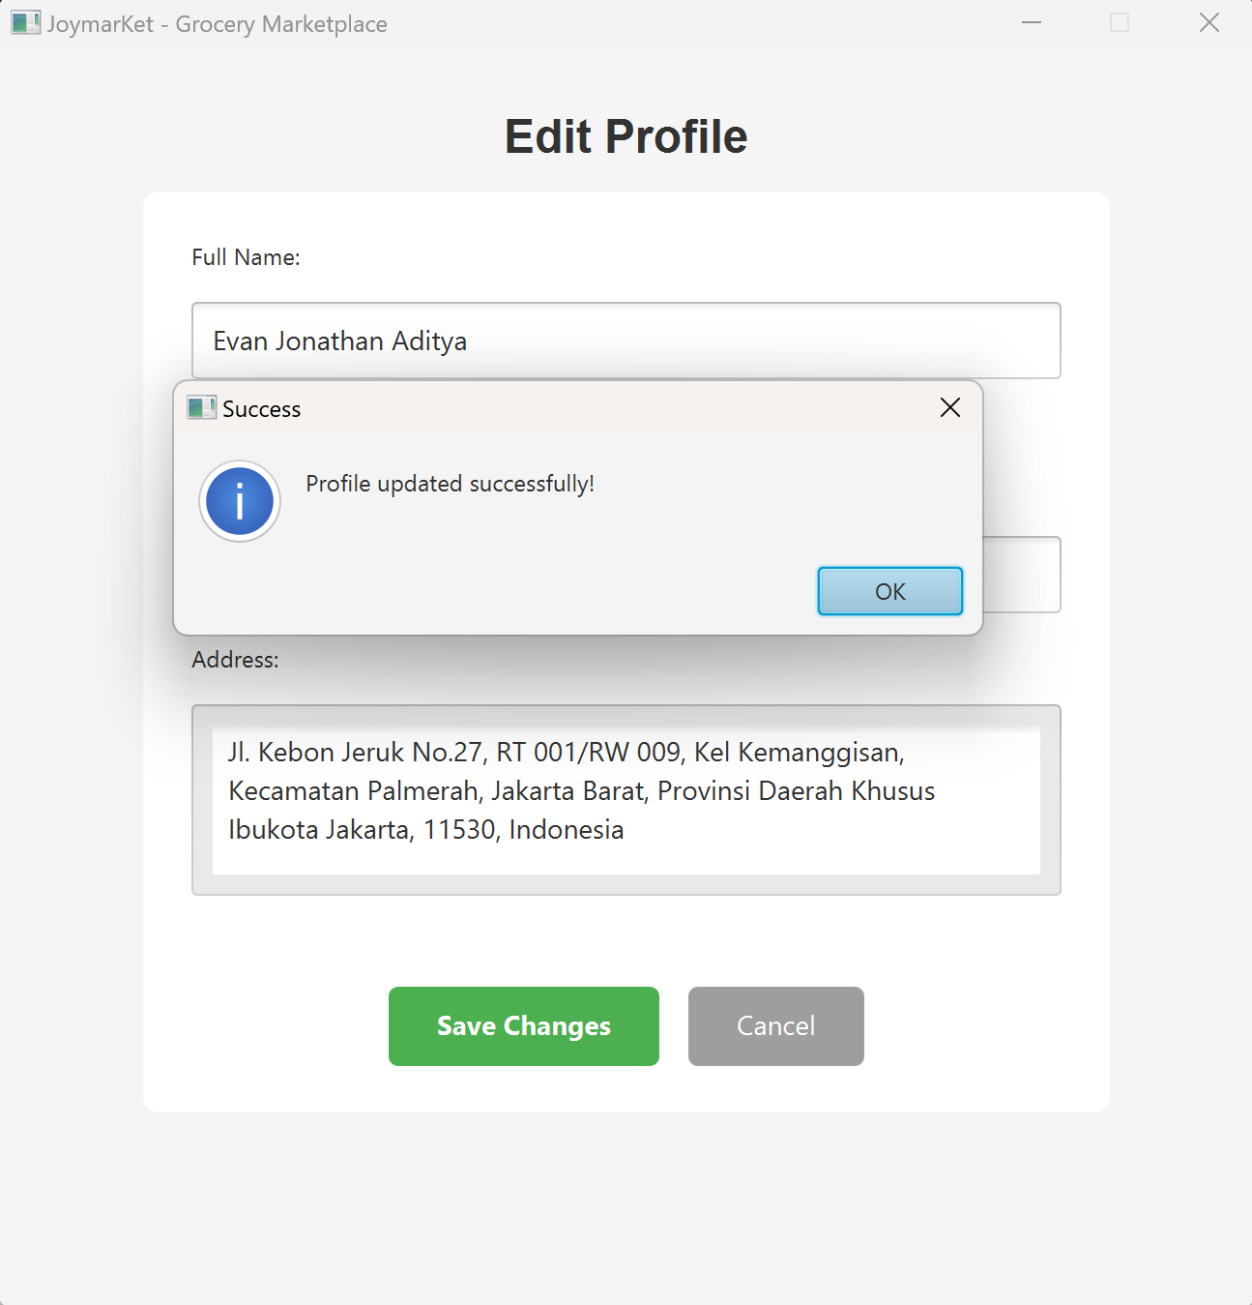
If you wish to log out from your account, click Log Out on your dashboard. Your account will be logged out and you will be directed back to the Login Page.

